- RED MACD LINE (pic below)—The MACD is one of the most popular trading indicators of traders. I am only going to use the red signal line for this system. We do not need the main line or the histogram. The one being used is an adaptation of MACD of MT4. I will call it the NB MACD. Later I will be putting two Stochastic Oscillator lines with it and they will give you accurate information of how price is acting. Also on the screen are 3 yellow lines produced by a Stochastic Oscillator. I will explain these in just a moment.

One of the downfalls of MACD is that it is a lagging indicator and will get you into trades too late. It also reacts slowly to price change, so we add some more lines to help in making decisions later. However, this is what you need to know from this line. Below you will see a 4H MACD signal line on a GBP/JPY. This line will give you several indications of price action over a 4 week period.

There are 3 things this line will tell you and all 3 shows up over a period of 4 weeks. I labeled each week 1, 2, 3, 4 in white numbers.
- Letter A — When MACD red line is near or past the 85 line or the 15 line you are near turn around territory. You will find this to be true most of the time but there is an exception. I will cover this later. For when you see price in this area you can look for a turnaround in price. How to identify this better will be explained later. You can see price turn around at the beginning of week 1, week 2, and possible in week 4.
- Letter B – MACD red line is at a 45 degree angle. This is showing good price movement and you have a solid trend going in a particular price pair. Week 1 is particularly strong; Week 2 has a good retracement and another at the beginning of week 4. Seeing this angle helps you to stay in a trade longer and reap the benefits of riding the trend.
- Letter C – MACD red line is flat and signifies that price is not trending or is just bouncing between a resistance and support level. You see this very clearly in later week 2 and all of week 3.
- So in conclusion the MACD red line gives you a very clear visual of general price movement for the last 4 weeks.

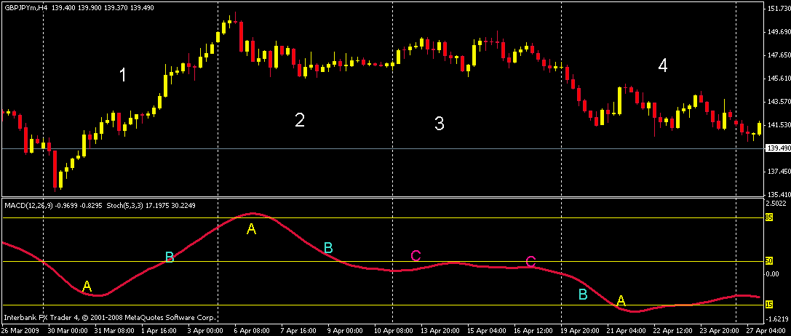.

- The next picture below is a blue line from the Stochastic Oscillator. There is a Stochastic Indicator and a Stochastic Oscillator. We only use the oscillator in this system. We also change its functions from low/high to close/close and we use Linear Weighted for the MA method. The numbers used are 14-5-3. We over lay this on the MACD screen and we have a MACD Sto cross indicator. A very useful one as you will soon see. If you have ever used Sto indicators in trading you know that they go overbought or oversold too quickly and are very poor at predicting long trends. However, mixed with a slow indicator, like MACD, you get a very quick visual on what is happening with price. It has several functions:
  - If the blue Sto line is greater than the MACD red line- you are in an uptrend and if it is less than the red line you are in a downtrend. As you can see this becomes a very easy read.
  - The oscillator also plots a yellow line at the 85, 50, and 15 marks. When you are above 85/below 15 you are nearing turn around territory. When the blue line crosses the red you have a change of direction in price action. It now becomes obvious to you that when these two lines close in on each other it is time to close your trade and to get ready to go in the opposite direction.
  - Look at week 1 letter A – When the blue line crosses the red line we have a change of direction in price action. As it nears the 100 level it flat lines and it takes almost a week to catch the red line. A nice long profitable trade. Even when it hits 100 or 0 some of the biggest price moves are yet to come. In week 2 you have the same thing but this time price action is much smaller but there still was a nice move there. We will add a third Sto line to help in the decision making process.
  - The one rule you cannot disobey in this system is you do not enter any trades unless the blue line is near, above/below the 85/15.
  - So in conclusion, if the blue is above red you buy only and if blue is less than red, you sell only. When they are converging above or below the 15/85 lines you turn the EA on.
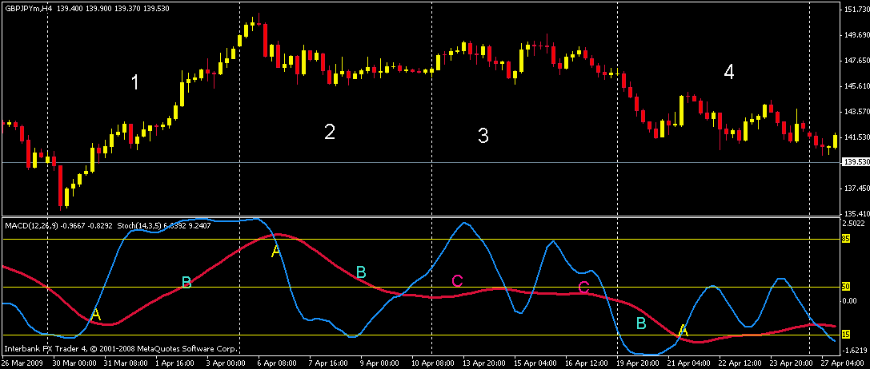

THE WHITE LINE
- Knowing how to read the white line as compared to the blue is a key to trading this system.
  - If the white and blue go up/down together, the tighter they are the stronger the move and the longer you want to stay in.
  - The farther apart they are, the weaker the move and the less time you will want to stay in the trade. In the pic below I labeled the strong moves, good moves, and the weak moves. Notice the distance between the white and blue lines as they go up or down. White moves but blue does not get out. The tighter they are the more you want to stay in the trade.
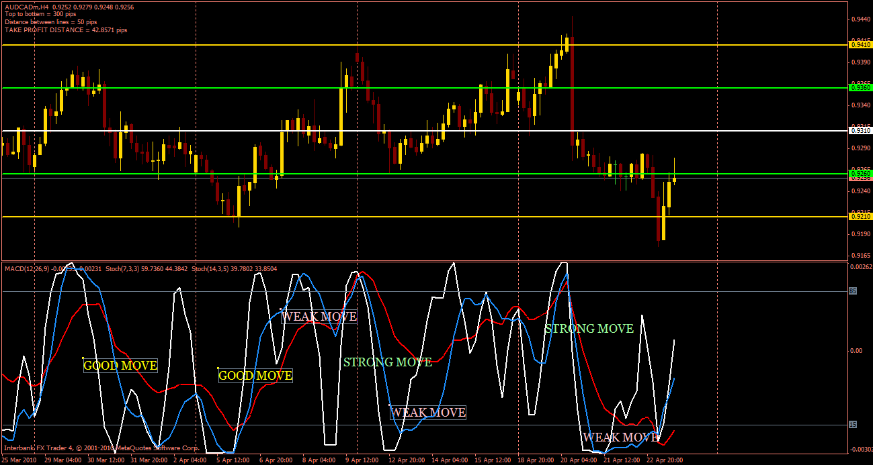
  - So in conclusion, all lines above or below 85/15 and near the top or bottom of the gold lines on the sixths indicator becomes your entrance point. These are nice and easy to read and to do trades.

- SwingMan’s indicator—Swingman developed an indicator which draws lines on the screen when RWB meet the conditions of above/below the 85/15 lines. He also had an indicator window which is included with the other indicators but I only use his lines because I am used to the RWB lines for reading price movement. Anyway if it ever comes on it means the RWB has met the trade conditions. Confirm with the sixths lines and turn on the indicator. Purple for sells aqua for buys.
